CS 255 System Design Document Template

UML Diagrams

UML Use Case Diagram

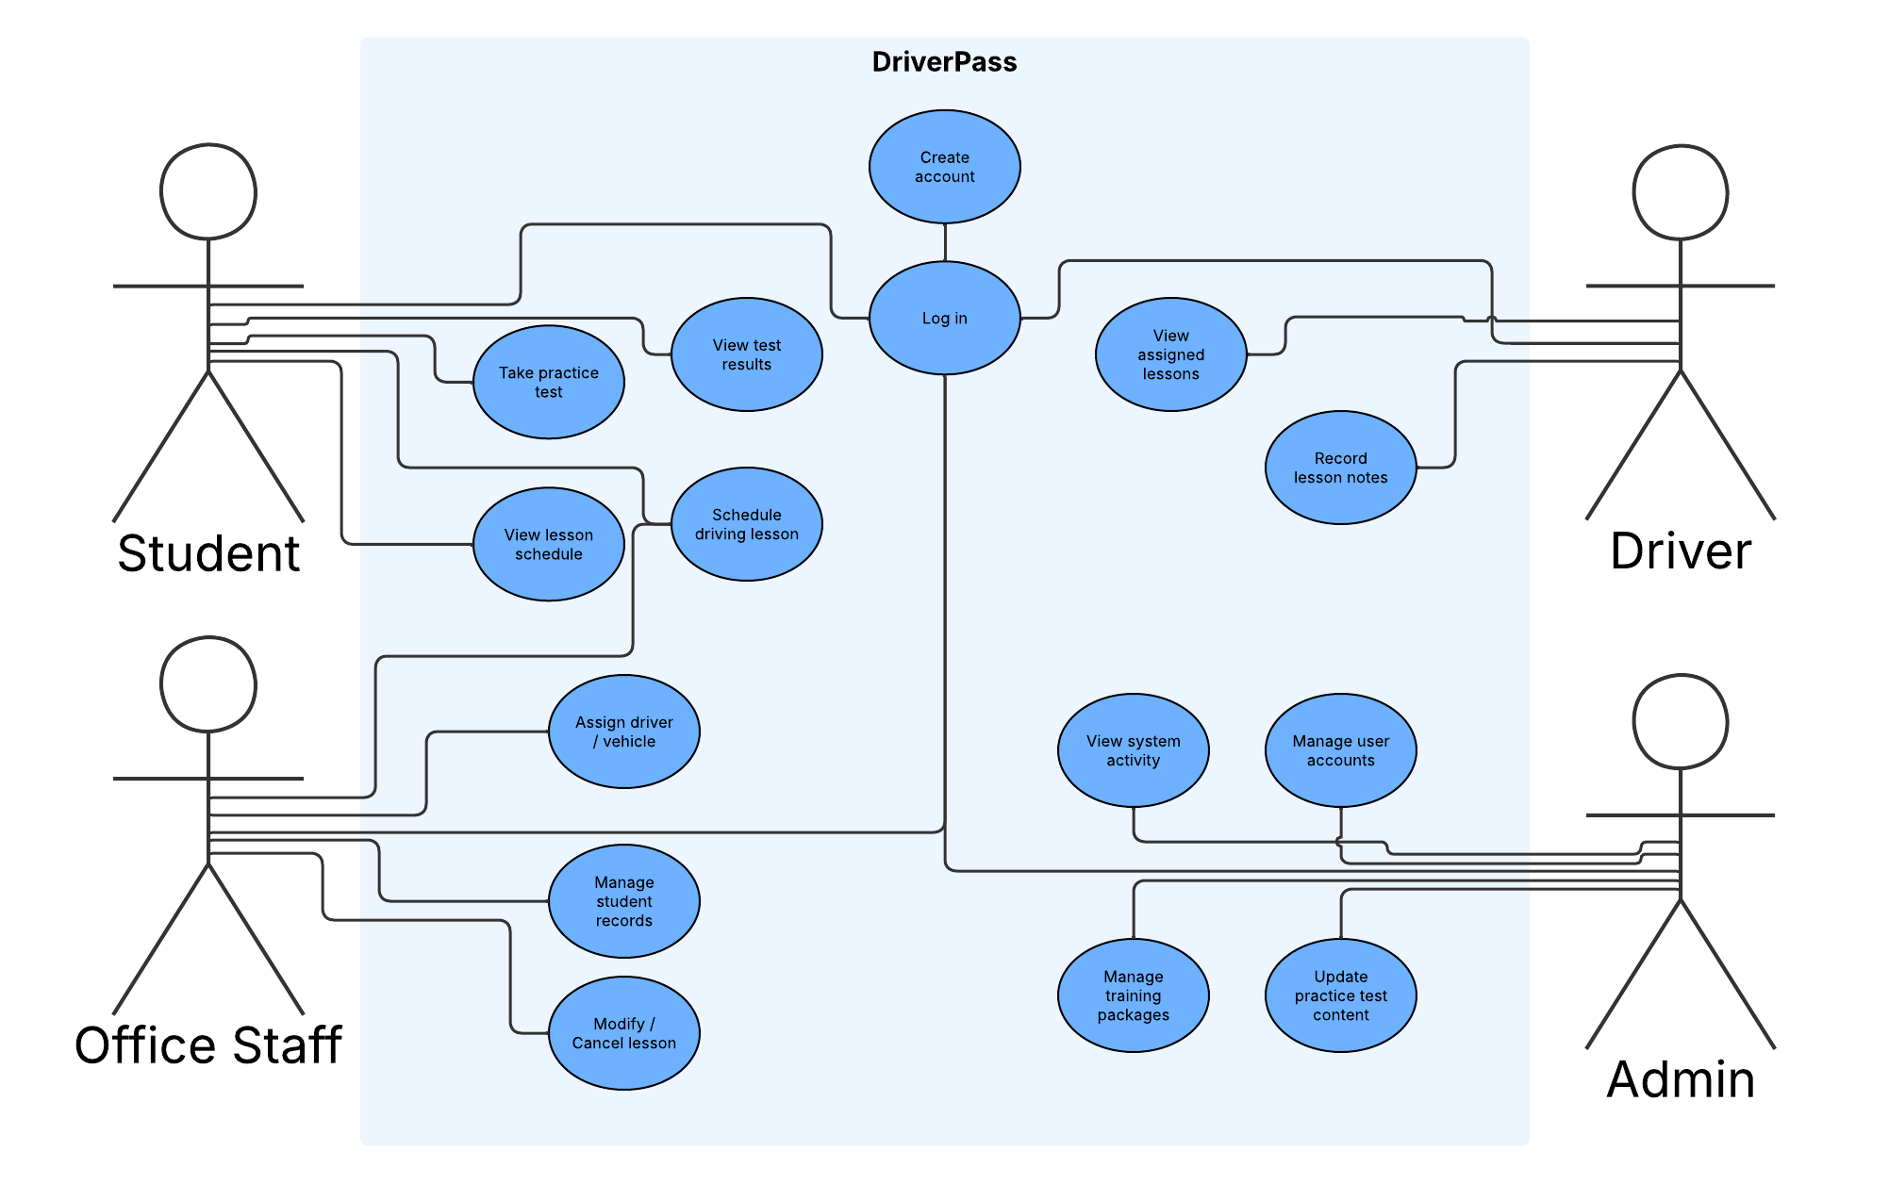

UML Activity Diagrams

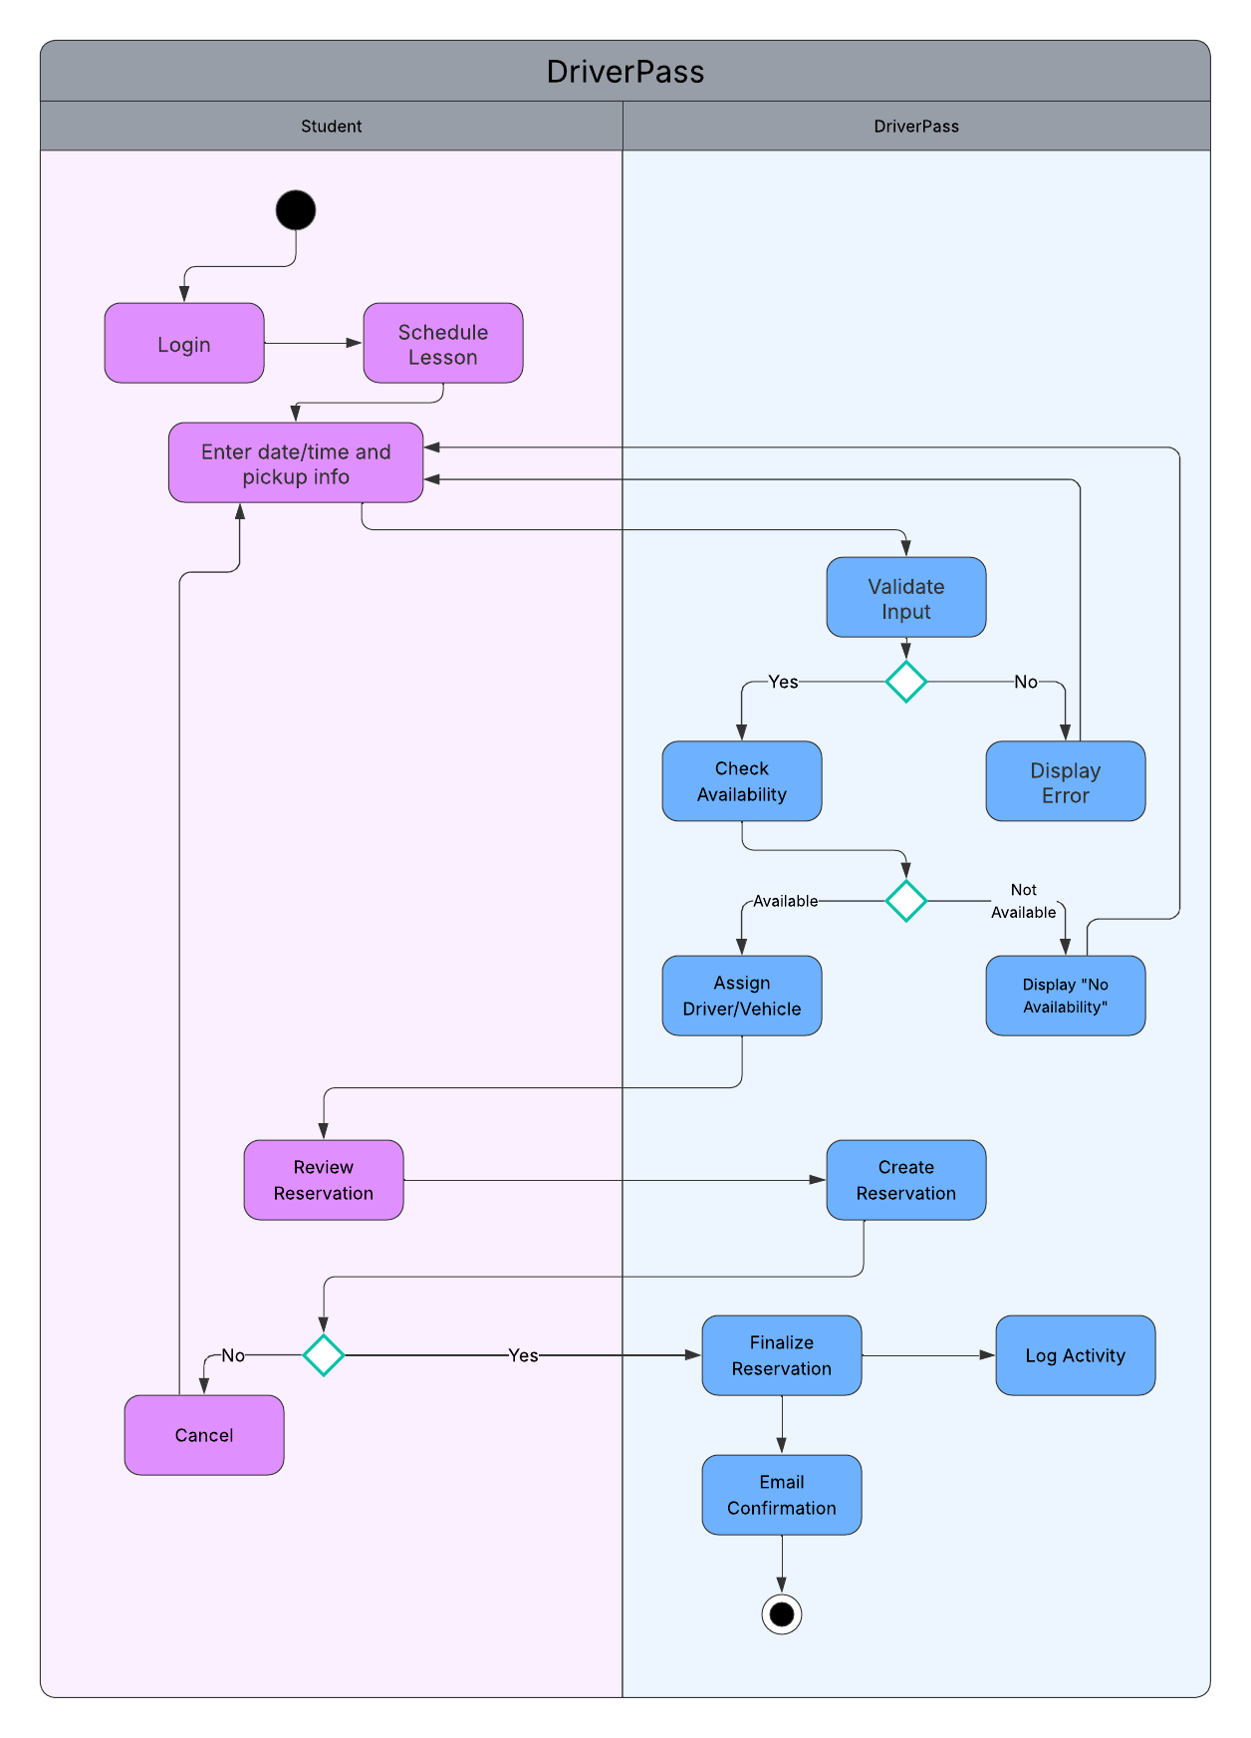

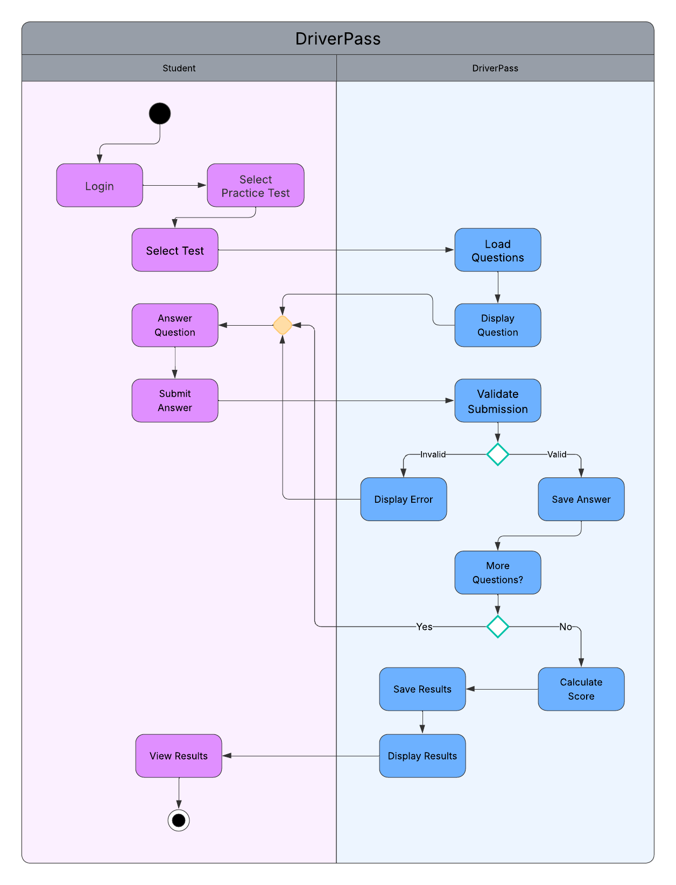

UML Sequence Diagram

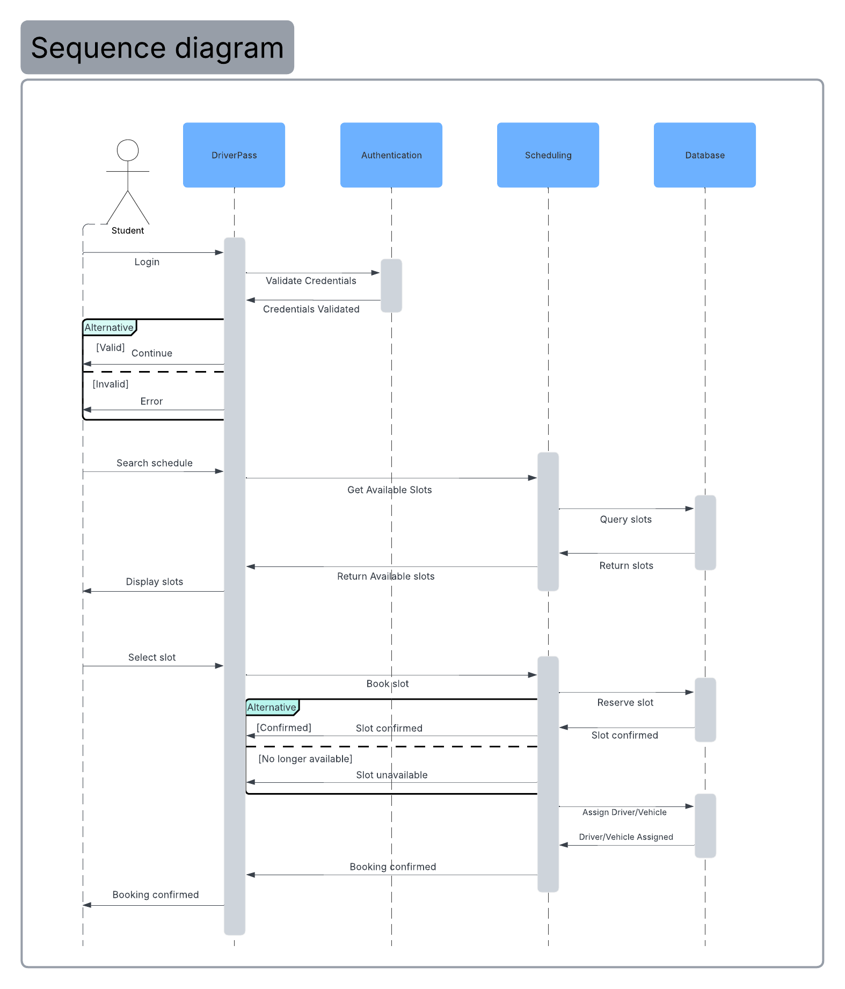

UML Class Diagram

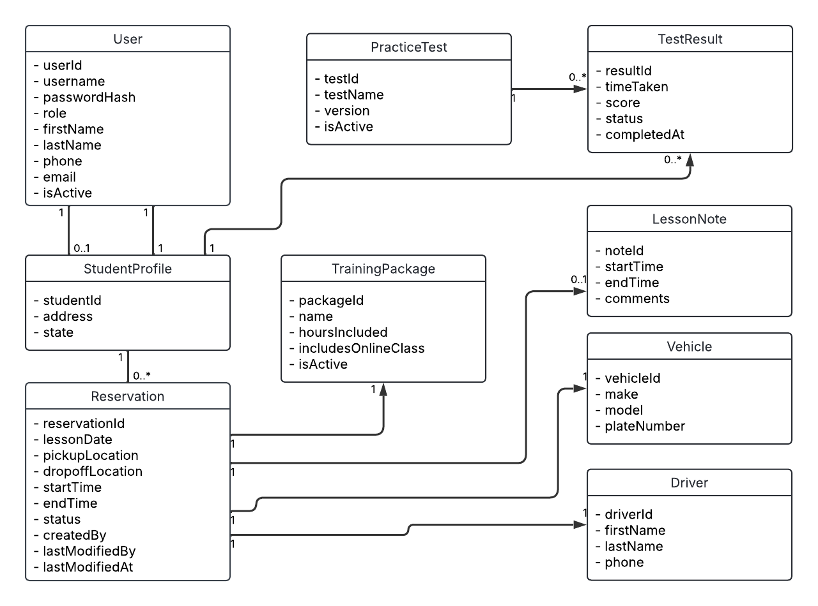

Technical Requirements

The following technical requirements support the proposed system architecture and UML design:

Hardware

- Cloud-hosted application servers to support web traffic and business logic.
- Cloud database server/storage for user accounts, reservations, lesson notes, and test results.
- End-user devices: desktop/laptop or mobile device capable of running a modern web browser.

Software

- Web-based application hosted on a scalable cloud platform.
- Relational database to store persistent system data.
- Web browser compatibility: Chrome, Edge, Safari, Firefox on Windows/macOS and common mobile browsers.

Tools

- Identity and access management supporting role-based access.
- Logging and auditing capability to track who created, modified, or canceled reservations and other records.
- Email and notification service to send booking confirmations and system update notifications.

Infrastructure / Security

- HTTPS/TLS encryption for all client–server data exchange.
- Account lockout controls after repeated failed login attempts.
- Password reset capability for users and admin account management functions.
- Automated backups and monitoring handled by the cloud provider to support availability and recovery.
- External DMV update ingestion process (integration or admin-managed update workflow) to keep practice content current and notify admins when updates occur.

